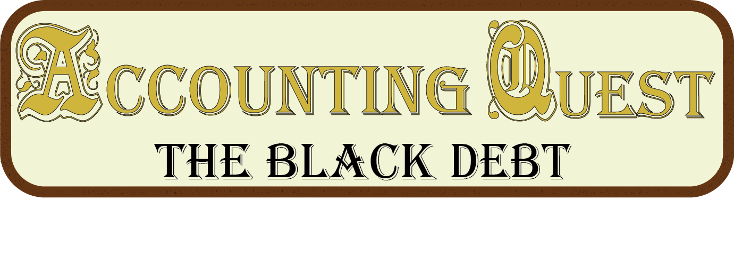

Scope Document

Karl Pytte – bitRaid Games

Contents

Objectives and Approach 2

Deliverables 2

Approach 2

Communication & Data Organization 2

Cameron Dadd 3

Chelsea Poots 3

Critical Tasks 4

Task Shedule 4

Documentation – 08/07/19 5

Alpha Prototype – 15/07/16 5

Initial art assets – 22/07/16 5

Beta Verson – 29/07/16 5

Polish and Playtesting – 05/08/16 5

Development of Release Version – 12/08/16 5

Release Shipment – 19/08/16 6

Risk Management 6

Critical Design Flaw – High Risk 6

Competing Workload – High Risk 6

Personal Injury (Mental) – Medium Risk 6

Personal Injury (Physical) – Low Risk 7

Data loss – Low Risk 7

Unforeseen Disaster– Low Risk 7

References 8

# Objectives and Approach

This section is concerned with the deliverables of the project, and the project management methodology employed to reach said goals.

## Deliverables

This project aims to complete the Educational Game “The Black Debt” and have the final release ready for shipment by 10pm on Friday the 19th of August. The game will feature all of the in-scope deliverables as outlined in the Game Design Document, and it will feature a great deal of mechanical and aesthetic polish.

The purpose of the game is to increase the overall student GPA through the use of this game as a tool for learning alongside regular classroom instruction. Ideally this game will be introduced into the school curriculum and be freely available to students and teachers alike. In addition, there is a drive to work in opposition to the belief that games do not belong in the classroom, and increase the acceptance of games-assisted learning through WA schools. Ideally this game will meet the standards of the Curriculum standards Authority of Western Australia, and receive their endorsement.

## Approach

To achieve this end and meet the deadline, rigid project management methodology will be adhered to. The Spiral method of project management will be used (Boheim, 2008), allowing for weekly testing, feedback and analysis. This cycle will ideally prove the most efficient method for a self-directed project.

The spiral methodology allows for a more flexible development cycle as at the end of each week there comes an opportunity to re-assess the project based on changing circumstances, and establish realistic goals for the next development cycle. This will allow for both the reduction and potentially expansion of deliverables based on the opportunities provided.

Self-assessment will take place in the form of blog posts, checklists and facilitator meetings, taking place roughly once a week throughout the 12 week development period. This does not restrict the means for shorter cycles, and once issues have been identified they must be dealt with immediately rather than waiting for the end of the cycle to re-assess.

# Communication & Data Organization

Currently any and all work done through associates at SAE Quantm will be handled through the Slack channel, and any meetings will be arranged on a weekly basis. The primary resource for data storage is GitHub, where any and all work done on the project is backed up daily to their cloud servers. Local storage is currently done on two machines, as well as a backup flash drive.

## Cameron Dadd

Cameron has been working with me to create a logo and professional image for my personal company. We have been communicating through personal contact and Slack, as well as sharing files through Google drive. The bitRaid logo shown below is his work based on my commission.



## Chelsea Poots

Chelsea has been doing character designs and portraits for the two main characters based on the details in the art bible. We have been communicating through personal contact and Slack, as well as sharing files through Google drive. An example of her designs can be seen in the sketch below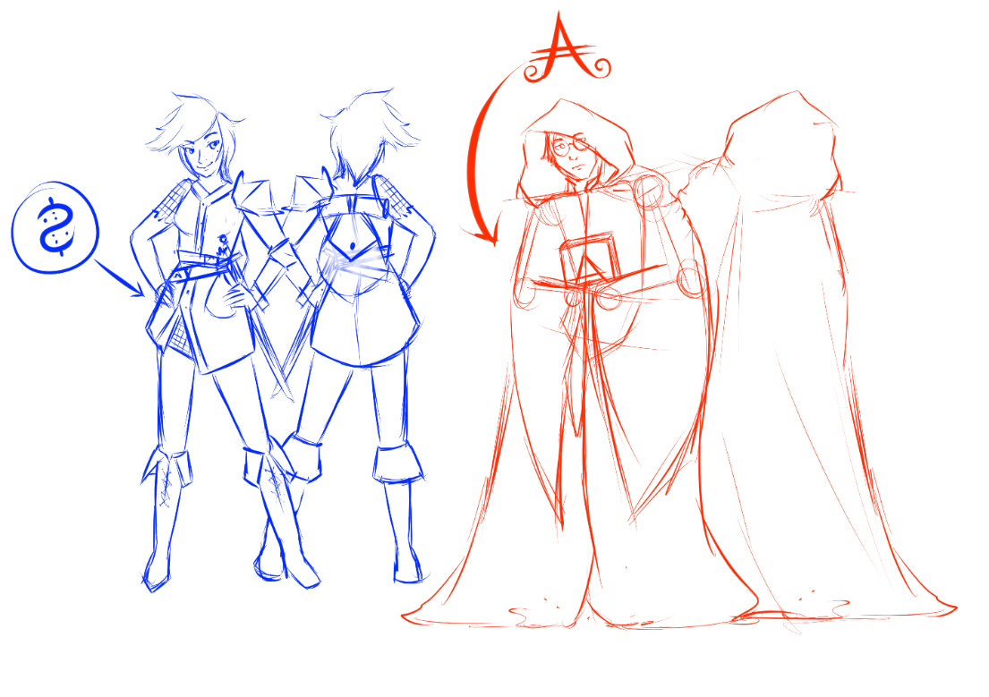

# Critical Tasks

These are the tasks requiring completion, their dependencies, as well as the time estimates

|  |  |  |
| --- | --- | --- |
| Task description | Time estimate | Dependencies |
| Quest system (1 & 2) – multiple choice | 1 week | none |
| Quest system (3) – keyboard input | 2 week | Quest system (1 & 2) |
| Economy system – villagers & towns gathering (& processing) resources | 1 week | Overworld map & towns |
| Overworld map construction – 5 tiles and towns | 4 days | none |
| Town hub construction – mapping of points of interest | 3 days | none |
| Town window construction – individual points of interest | 4 days | Town hub construction |
| GUI navigation system – navigate effectively between all sections of the game | 1 week | none |
| Tile construction (not outsourced) – creation of unique tile models | 1 week | Overworld map |
| Trade System – mechanical system for trading between towns to generate gold | 2 weeks | Economy system |
| Quest content generation – creation of assessable content for quests | 2 weeks | Quest system (1 & 2) |
| Econonomicron – creation of content to teach assessable content. | 3 weeks | GUI navigation |

# Task Shedule

This section is concerned with the weekly major milestones in the project, structured alongside the spiral methodology.

## Documentation – 08/07/19

These living documents are essential to ensure the project moves forward as intended, they consist of

* Project Plan and Scope
* Game Design Document
* Marketing Plan

## Alpha Prototype – 15/07/16

This is a version of the project that contains all of the working key features, these are:

* Accounting quest system (level 1 & 2)
* Overworld navigation system
* Town Economy system
* Town navigation system
* Trading System
* Combat system

Failure to have these systems working and communicating as intended by this time will result in them being removed from the project.

## Initial art assets – 22/07/16

Greybox assets will begin to be replaced with some content provided by animators and sound-design professionals working alongside this project. In addition there will be more content created to flesh out the core mechanics.

## Beta Verson – 29/07/16

This version contains all of the assets and content that are intended to be included in the project. Ideally once this deadline has passed, no additional content is needed to be added to the game and the primary focus will be on marketing, bugfixing and polish.

## Polish and Playtesting – 05/08/16

This section will be involved with getting the game to a level of polish that it can be ideally showcased at a public event, and not appear to be still in development. This section will have been met successfully if this is the case.

Development of Release Version – 12/08/16

By this stage all of the art and audio assets should have been added to the game, as well as there being no mechanical faults, it should be ready to ship at a moment’s notice.

## Release Shipment – 19/08/16

Final version is sent to the stakeholder, by this point no more work may be done, and the game is considered complete.

# Risk Management

This section has to do with elements that may impact the completion of the project, the risk of them occurring, as well as the strategies done to minimize the risk or mitigate the damage.

## Critical Design Flaw – High Risk

There may exist an aspect in core design of the project that in some way negatively impacts its feasibility as a product. This could include an improper analysis of the target market, an inability to scope correctly, or some flaw in the physical design of the game that makes it impractical. Proper playtesting and extensive research will be conducted to minimize the risk of this occurring, or ensure that if they exist that they are identified early. Should a critical design flaw be identified, this will result in the project being immediately reworked around this new issue.

## Competing Workload – High Risk

As it stands this project is not being conducted in a vacuum; other projects and tasks exist that compete with it for development time. Proper time management, budgeting, as well as realistic workload expectations exist to prevent this from becoming an issue. Should a clash in workload exist that forces insufficient time to be rationed between projects, an assessment of priorities will be conducted, eventuating in a new schedule that maximizes the overall return for time spent. Should this new schedule not be in this project’s favor, the facilitator will be notified immediately.

## Personal Injury (Mental) – Medium Risk

This includes situations such as trauma, fatigue, or personal instability that impacts in some way my ability to cope with the demands of this project. Strategies in place to mitigate this are a reliance on proper structure in terms of time management, positive thought patterns, and attempts to keep aspects of my personal life stable. If these mechanisms do not prove effective enough, my supervisor will be notified at the earliest opportunity, and the project scope will be re-assessed in light of the changes needed.

## Personal Injury (Physical) – Low Risk

These include illness (pathogen based), bodily harm, or some other factor that inhibits my ability to physically perform the tasks required to complete the project. The risk mitigation strategies include avoiding high-risk scenarios in which my personal safety is at risk (reckless driving, unsafe behaviour) as well as ensuring that I avoid situations where I might come in contact with communicable illness. Should an event occur that incapacitates me in some way, I will make every effort to contact my Facilitator to notify them of the situation.

## Data loss – Low Risk

This will occur from situations such as storage device failure that results in loss of critical data. The use of online version-control software, as well as weekly local backups, will assist in making sure that any data loss is minimized. Should data loss occur, the damage will be assessed and if the data proves irrecoverable, the project will be rolled back to the most recent stable version.

## Unforeseen Disaster– Low Risk

This can include wide-spread catastrophic events that in some way impact the ability to complete the project, issues such as flooding, fire, or terrorism. Vigilance as to the risk of these disasters occurring is required on a case-by-case basis, and should they eventuate the project will be re-assessed in light of their occurrence.

# References

Boheim, B. W. [article]. (2008). A Spiral Model of Software Development and Enhancement. Retrieved from http://csse.usc.edu/TECHRPTS/1988/usccse88-500/usccse88-500.pdf